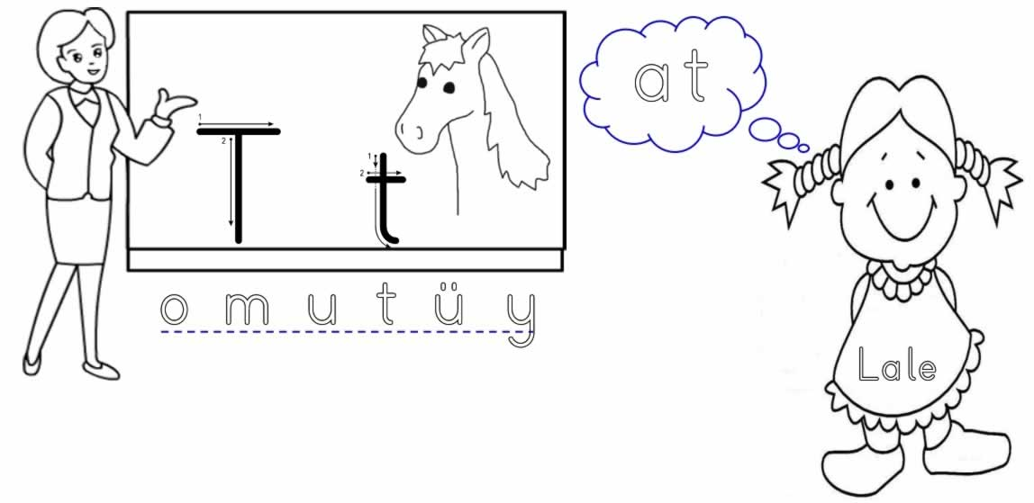

t t t t t t t t t t t t t t t

t t t t t t t t t t t t t t t t t t t t

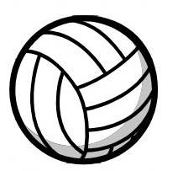
t t t t t t t t t t t t t t t t t t t t

t t t t t t t t t t t t t t t t t t t t

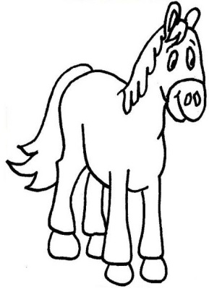
t

t

t

t
