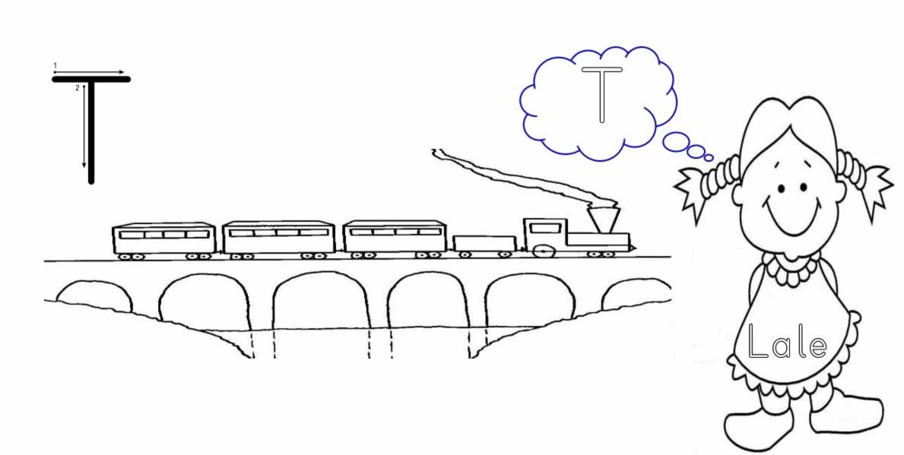

T T T T T T T T T T T T

T T T T T T T T T T T T T T T T

T T T T T T T T T T T T T T T T

T T T T T T T T T T T T T T T T

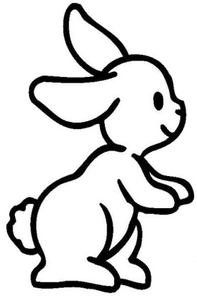
T T T T T T T T T T T T T T T T

T

T

T
