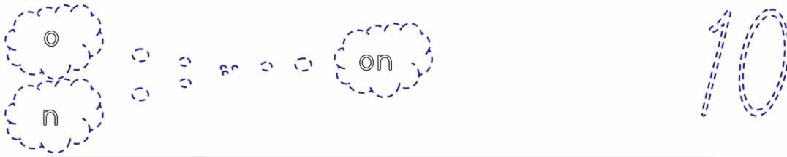

on on on on on on on on on on on

on

ono ono ono ono ono ono ono

ono

no no no no no no no no no no

no



