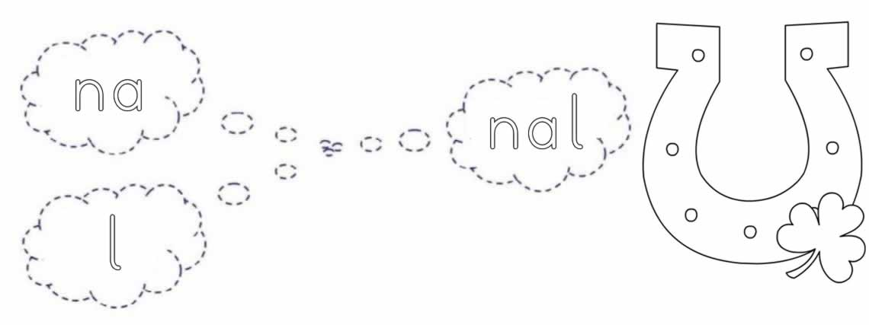


nal nal nal nal nal nal nal nal nal

nal nal nal nal nal nal nal nal nal

nal nal

nal nal

nal

nal

