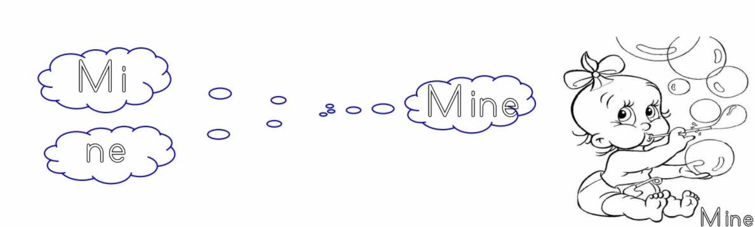


M M M M M M M M M M M

M M M M M M M M M M M

M M M M M M

M M M M

M M M

M M

M

