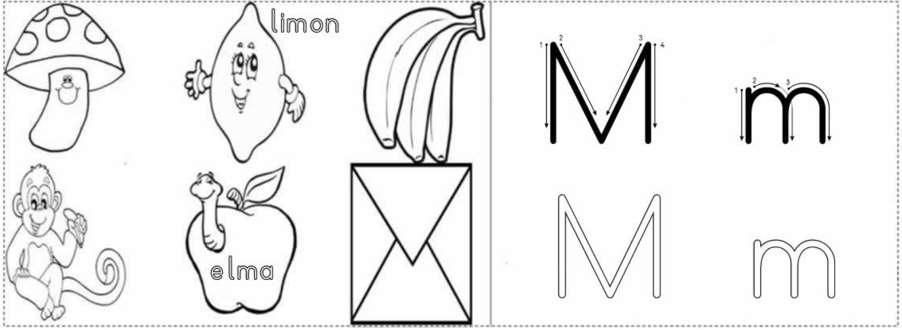

m m m m m m m m m m m
m m m m m m m m m m m
m m m m
m m m m
m m m

m m m


