
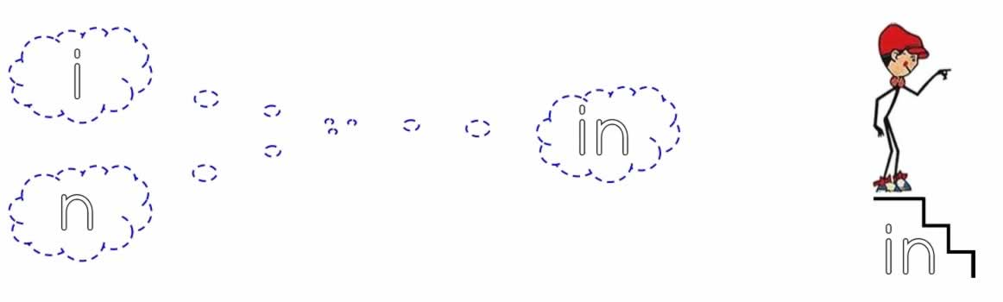

in in in in in in in in in in in in in in

in in in in in in in in in in in in in in

in in in in in in in in in in in in in in

in in in

in in

in

