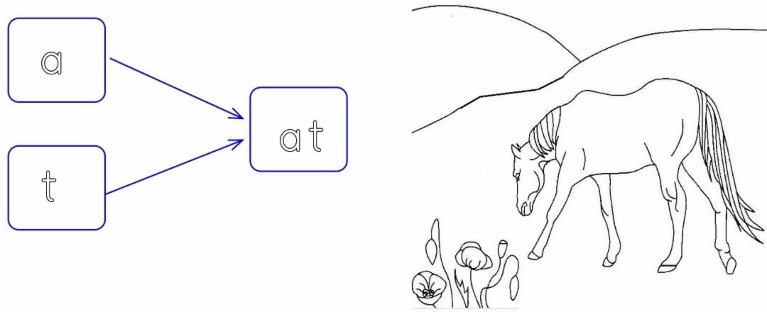

at at at at at at at at at at at

at

ata ata ata ata ata ata ata ata

ata

ta ta ta ta ta ta ta ta ta ta ta

ta


