
ALİ

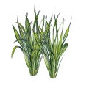
Ali ata al.

Ali elli ata at.

Ali ite et al.

Ali ite elli et at.
Ela, at , it et 7.

Ali ata atla, iti elle.
