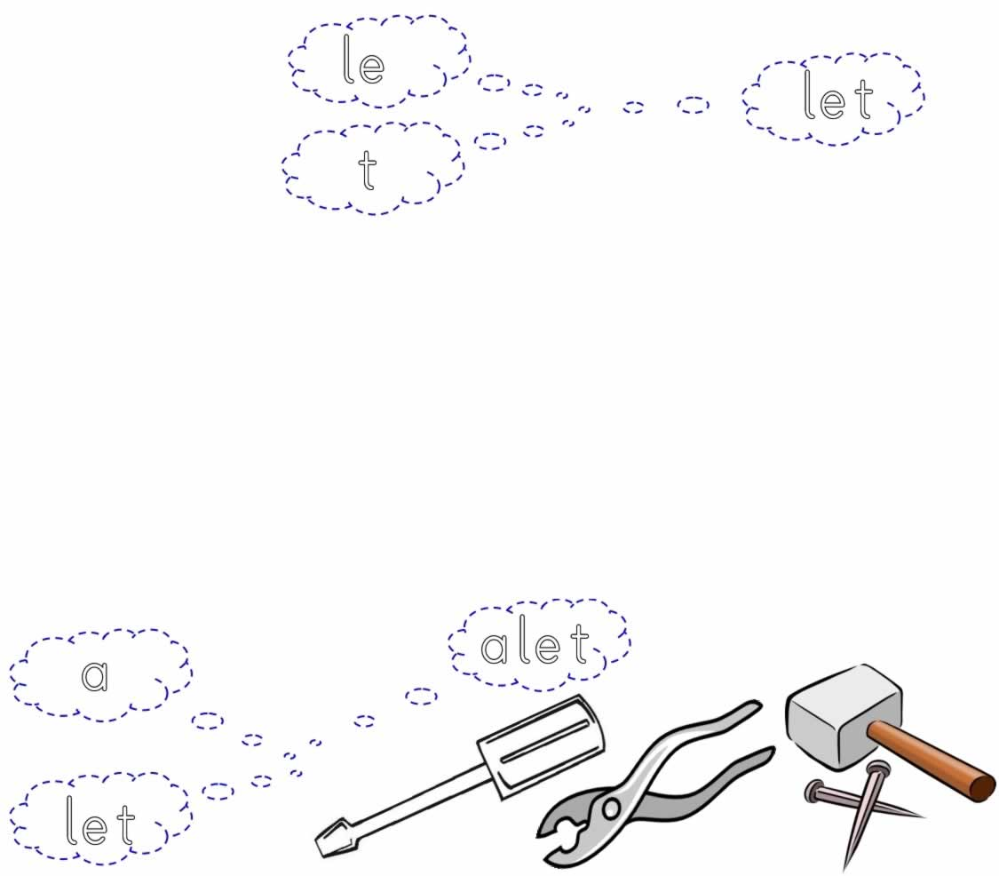
let let let let let let let let let let

let

alet alet alet alet alet alet alet

alet alet

alet



