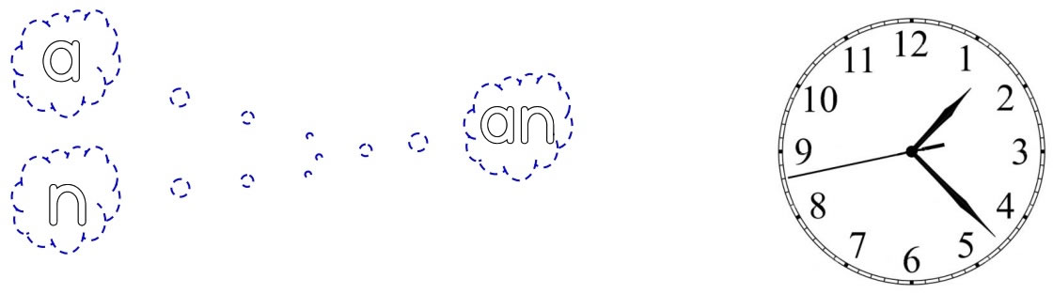

an an an an an an an an an an

an an an an an an an an an an

an an an an an an an an an an

an an an an an

an an an

an an

an


an
