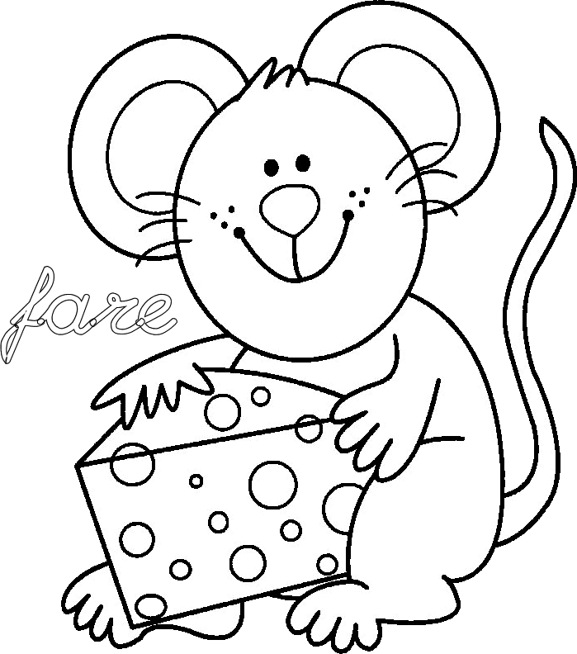
f f f f f f f f f f f f f f f f
f f f f f f f f f f f f f f f f
f f f f f f f f f f f f f f f f f
f f f f f f f f f f f f f f f f f
f f f f f f f f f f f f f f f f f
f f f f f f f f f f f f f f f f f
f f f f f f f f f f f f f f f f f
f f f f f f f f f f f f f f f f f
f f f f f f f f f f f f f f f f f
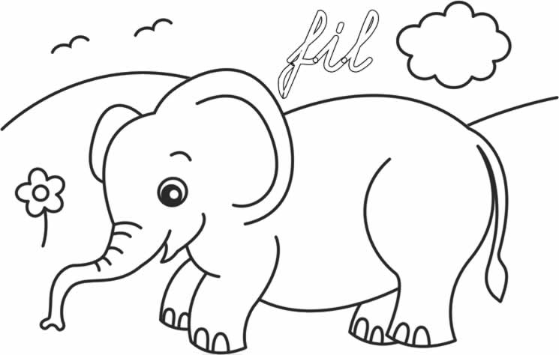
f f f f f f f f f f f f f f f f f

f f f f f f f f f f f f f f f f f

