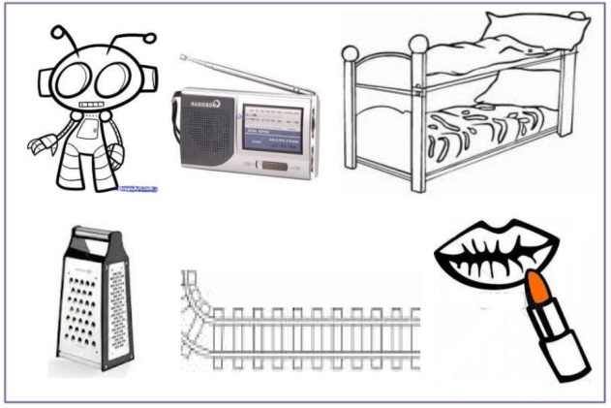
r r r r r r r r r r r r r r r
r r r r r r r r r r r r r r r
r r r r r r r r r r r r r r r
r r r r r r r r r r r r r r r
r r r r r r r r r r r r r r r
r r r r r r r r r r r r r r r
r r r r r r r r r r r r r r r
r r r r r r r r r r r r r r r

r r r r r r r r r r r r r r r

