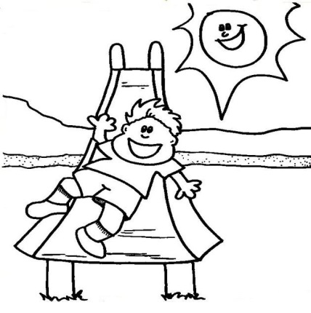


Ali Ali Ali Ali Ali Ali

Ali Ali Ali Ali Ali Ali Ali Ali Ali Ali

Ali Ali Ali Ali Ali Ali Ali Ali Ali Ali

Ali Ali Ali Ali Ali Ali Ali Ali Ali Ali

Ali Ali Ali Ali Ali Ali

Ali Ali Ali Ali

Ali Ali Ali

Ali Ali

